Brandywine Red Clay Alliance is once again partnering with Delaware Nature Society, Mt. Cuba Center and the Kennett Area Park Authority for the
ANNUAL
RED CLAY VALLEY CLEAN UP

Saturday, March 29, 2025
8:00 AM- 12:00 PM

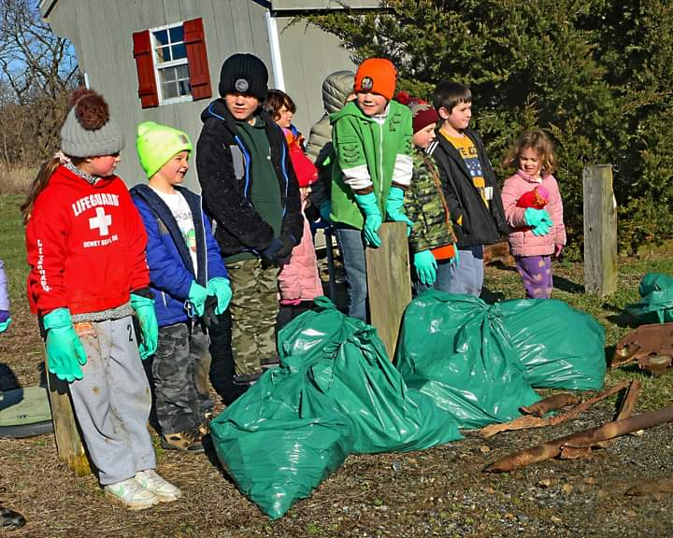
Photo credit: Chris Barber
Register now to participate in our Annual Red Clay Valley Clean Up event to keep roads, parks, and streams in our area clean and beautiful.
Volunteers will assemble at 8:00 AM at either the Ashland Nature Center in Hockessin, DE, Anson B. Nixon Park or the Kennett Area YMCA outdoor pool in Kennett Square to help with clean up of 98 miles of roads and streams in the Red Clay Valley watershed. More than 800 volunteers are needed for this effort, which is perfect for individuals, families, or school/civic groups. No experience necessary and all supplies will be provided. In the history of this event, over 439 tons of trash has been collected!

To register please visit our website at brandywineredclay.org
(Only one registration per group. Registration requested for groups of five or more.)
Questions? Email us jjordan@brandywineredclay.org

This event would not be possible without the following sponsors: Brandywine Red Clay Alliance, Bike Delaware, Chandler Funeral Homes, Delaware Nature Society, Wild Birds Unlimited-Hockessin, Kennett Area Park Authority, Mt. Cuba Center, Phillips Mushroom Farms, Veolia Delaware, WSFS, Flyway Excavating, Manfredi Cold Storage, Marty’s Contracting, Champion Trophies & Promotional Products, Constellation

